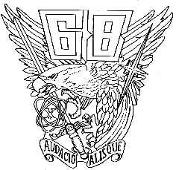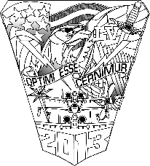

Reunion Schedule – 15 September
*Please make sure your badge is always on*
0800 – 1400 Late Check-In at Cadet Field House Lobby
0800 – 1530 Shuttle Rides – Cadet Field House to Base of Ramp
0800 – 1530 Open House – Terrazzo Area
0900 – 1030 Welcome/USAFA Senior Leader Update – Room F-1
0900 – 1100 Cadet Squadron Open Houses
0900 – 1500 Polaris Hall Open House
1100 – 1130 Cyber at USAFA Briefing – Room H-2
1100 – 1130 Institute for Future Conflict Briefing – Room H-14
1045 – 1300 Food Trucks at Arnold Hall
1145 – 1230 Mitchell Hall Luncheon – Please meet in front by center doors for briefing on entry
1145 – 1300 Food Trucks at Arnold Hall
1300 – 1500 Cadet Squadron Open Houses
1300 – 1330 Space Force at USAFA Briefing – Room H-1
1430 – 1530 Final Shuttle Rides – Base of the Ramp to Cadet Field House

